Table of Contents
Table of Contents 2
Introduction 3
Importing a IMS CC v1.0 package in to Blackboard 9.1 SP6 and SP8 4
Importing a IMS CC v1.0 package in to ANGEL 7.2 (or 7.3 & 7.4) 7
Importing a IMS CC v1.0 package in to Desire2Learn 9
Importing a IMS CC v1.0 package in to Moodle 1.9 11
Importing a IMS CC v1.0 package in to Moodle 2.0+ (IMS supporting versions) 13
Importing a IMS CC v1.0 package in to Canvas 15
Importing a IMS CC v1.0 package in to Sakai 2.9.1/Sakai 10 (with Lesson Feature) 16

Introduction
Common Cartridge is a set of open standards, freely available and without royalty, developed by a global industry consortium (http://www.imsglobal.org/). These standards, if followed by content developers and learning platforms, enable strict interoperability between content and systems. They also support great flexibility in the type of digital content supported (content can actually be applications) and where such content is located (content and applications in a Common Cartridge can be distributed). To know more about Common Cartridge, please visit the link - http://www.imsglobal.org/cc/index.html

To know about the current implementation and conformance status of Common Cartridge v1.0, please refer the chart on this link - http://www.imsglobal.org/cc/statuschart.cfm

Importing a IMS CC v1.0 package in to Blackboard 9.1 SP6 and SP8
- Login to Blackboard 9.1 with the instructor login
- Click on the course where the IMS Common Cartridge needs to be imported. (If no course has been created, put a request to administrator to create a blank course shell with required details (such as course name, enrollment etc…)
- Once you enter the course, you will see ‘Control Panel’ on the left frame. Click ‘Packages and Utilities’ link. It will expand with its options. Among those options, click ‘Import Package/View Logs’. See the screen grab below for more details.
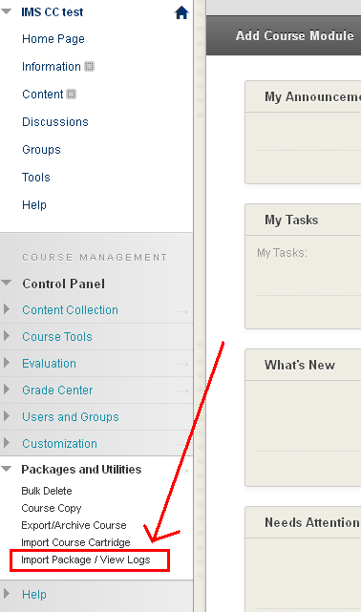
- On the ‘Import Package/View Logs’ page, click the ‘Import Package’ Button
- Browse the IMS CC package on your local machine by clicking ‘Browse’ button which there under the section ‘2. Select a Package’. Once the package is browsed, click the “Select All” button which is there under the section ‘3. Select Course Materials’. After it, click the ‘Submit’ button at the bottom (or top). See the screen grab for more details.
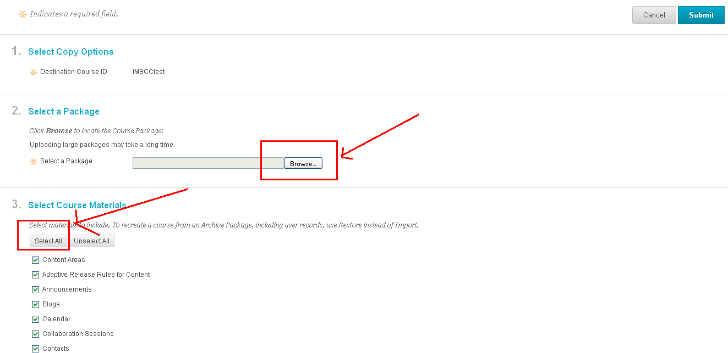
- Once we click the ‘Submit’ button, it will start the import process. This process depends upon the course file size and its contents.
- Refresh the page and after the import, the page will show its detailed import log (it’s a text file). This log file shows whether the import of the IMS CC package is successful or not. It will also shows if any ‘Warning’ or ‘Errors’ associated with the IMS CC import. Logs about ‘Warnings’ are negligible where as the ‘Errors’ needs to be resolved by the IMS CC developer. Any ‘Error’ on import means that the package has not imported successfully in to the course shell.
- Once the IMS CC is imported, we can review the items on the course content areas. The Course Content Area will be appearing on the left frame. The name of that content area will be defined on the ‘imsmanifest.xml’. Please see the screen grab for more details.
Screen grab of XML
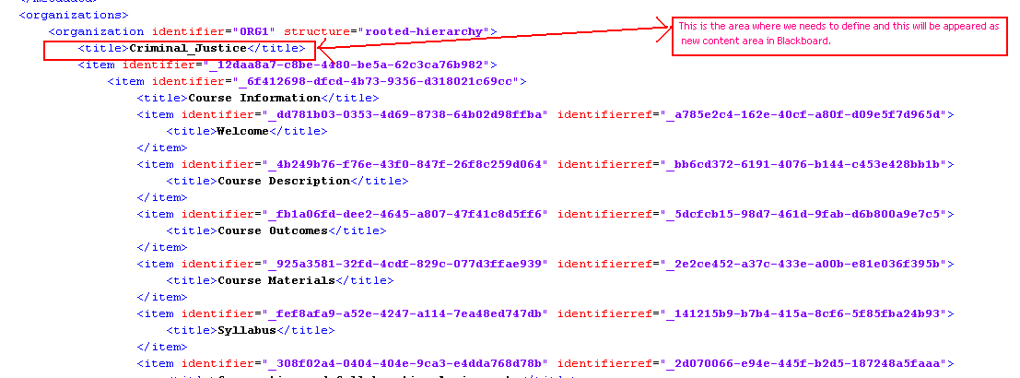

Screen grab of Blackboard
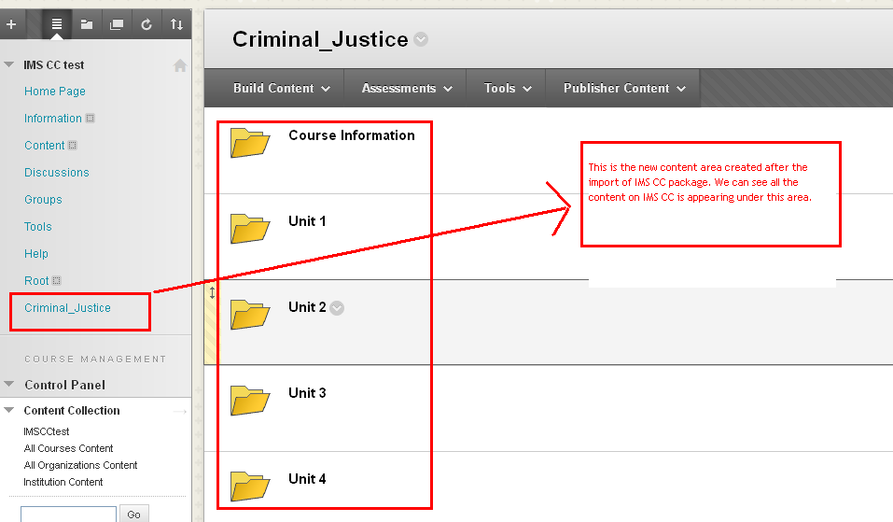
- All the discussions on IMS CC can be viewed under the ‘Discussion Board’ and the assignments will be restored under ‘Tests, Surveys and Pools’ Section.

Importing a IMS CC v1.0 package in to ANGEL 7.2 (or 7.3 & 7.4)
- Login to ANGEL with the instructor login
- Click on the course where the IMS Common Cartridge needs to be imported. (If no course has been created, put a request to administrator to create a blank course shell with required details (such as course name, enrollment etc…)
- Once you enter the course, you will see a ‘Manage’ tab on top. Click that tab will open a page named ‘Management Console’. Click the link for ‘Import Wizard’ under ‘Data Management’.
- On the ‘Content Import Wizard’ page, click the ‘Content Package’ link.
- Browse the IMS CC package on your local machine by clicking ‘Browse’ button. Check the checkbox for ‘overwrite existing files’ and click the button for ‘Upload File’. After the successful upload, click ‘OK’ button to continue the import process.
- The next screen on the import process is to determine which folder the IMS CC needs to import. In this page we have 3 options to choose the folder to upload the IMS CC package.
  - Top level ( it will restore in to the root folder of Lesson)
  - New Folder (it will restore in to a new folder) and
  - Existing folder (it will restore in to an existing folder of ANGEL course, if any)
See the screen grab below for more details. We can ignore those 2 check boxes in this page. Once we select the options, click ‘OK’ to continue.
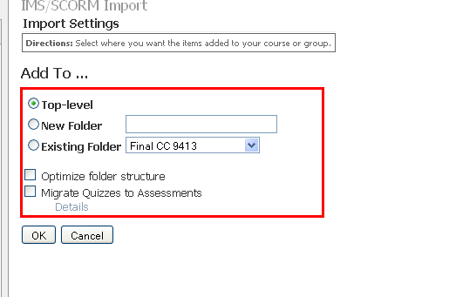
- After the successful import, it will show as the following screen grab. Click ‘OK’. That will complete the importing process.
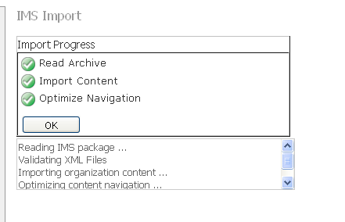
- Click the ‘Lessons’ tab on top and you can see the imported contents from the IMS CC on the folder which you have selected on the step 6.

Importing a IMS CC v1.0 package in to Desire2Learn
- Login to D2L with the instructor login
- Click on the course where the IMS Common Cartridge needs to be imported. (If no course has been created, put a request to administrator to create a blank course shell with required details (such as course name, enrollment etc…)
- Once you enter the course, you will see an ‘Edit Course’ link on the right top. Click that link.
- On the ‘Course Administration’ page, click ‘Import / Export / Copy Components’ link under the ‘Tools’ section.
- On the ‘Import/Export/Copy Components’ page, select the radio button for ‘Import Components’ and browse the IMS CC package from your local machine by clicking the ‘Browse’ button. Once the IMS CC package is browsed, click the ‘Next’ button to continue the import process.
- The next screen is for the ‘Preprocessing’. If the package is valid, it will show the green right mark as shown in the screen grab below. Click ‘Next’ button to continue.
- The next page is for selecting the course contents to import in to this D2L course shell. Click the checkbox for ‘Select All components’ and click ‘Next’ button to continue. See the screen grab for more details:
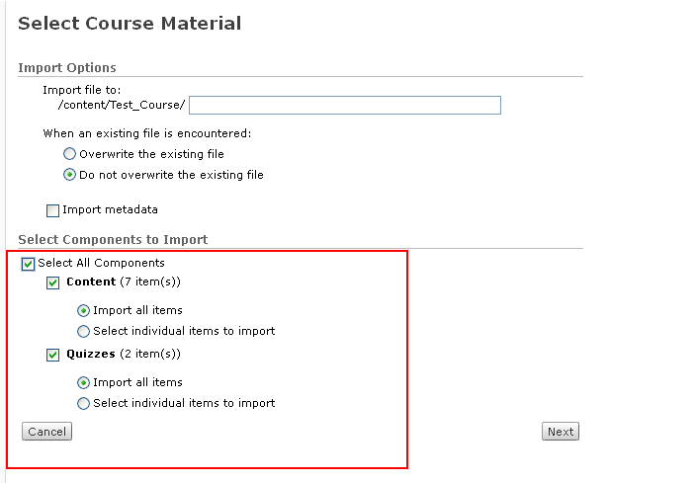
- The next page is for the confirmation. If you need to change any setting, then you can modify it else click ‘Next’ button to continue.
- The next screen is for the actual import process status. After the successful import, it will show the screen as below. Click the next button to continue.
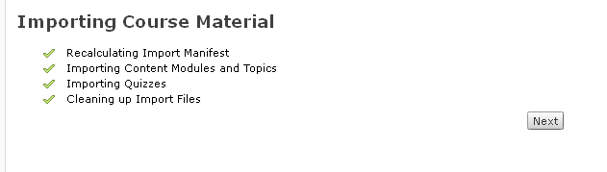
- This will complete the import process. The summary screen of the import will be appeared as shown below in the screen grab. Click the ‘return’ link to review the course contents.
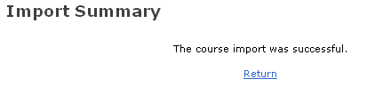
- Click the ‘Content’ link on the top and you can review all the contents imported from the IMS CC package.

Importing a IMS CC v1.0 package in to Moodle 1.9
- Login to Moodle with the instructor login
- Click on the course where the IMS Common Cartridge needs to be imported. (If no course has been created, put a request to administrator to create a blank course shell with required details (such as course name, enrollment etc…)
- Once you enter the course, click ‘Restore’ under the ‘Administration’ block.
- Click the ‘Upload’ a file button. Browse the IMS CC package from your local machine and click the ‘Upload this file’ button.
- Once the file is uploaded, it will be listed on the ‘Files/backupdata’ folder. Select the IMS CC package from the files and click the ‘Restore’ link. See the screen grab for more details:
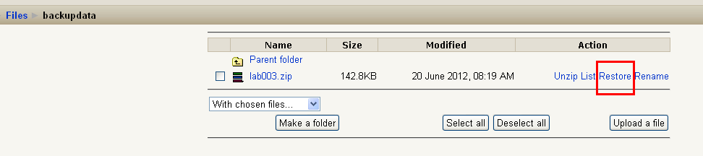
- On the next screen, click the ‘Yes’ button.
- Next page is for the information about the package and its contents. Click the ‘Continue’ button at bottom of the page.
Note: There might be a warning on this page relates to the schema and you can ignore it as that will not affect any issues with the restore process and its contents.
- Next page to determine where we need to restore this package on Moodle. Select ‘Current course, adding data in to it’ from the dropdown for the ‘Restore to’ option. No need to change the options and click the ‘Continue’ button at the bottom. See the screen grab below for more details:
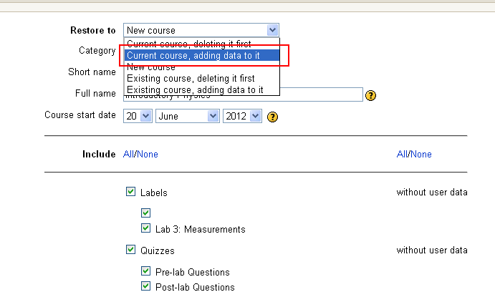
- Click the ‘Restore this course now!’ button on the next screen.
- Next page will show the restore process in details. After the successful restore, it will show as below. Click the ‘Continue’ button and you can review the course contents on Moodle.
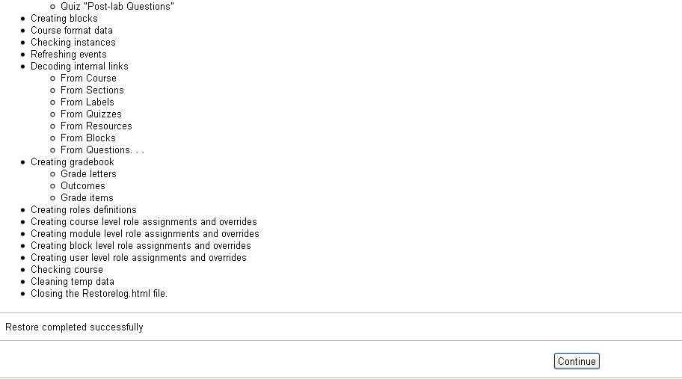

Importing a IMS CC v1.0 package in to Moodle 2.0+ (IMS supporting versions)
- Login to Moodle with the instructor login
- Click on the course where the IMS Common Cartridge needs to be imported. (If no course has been created, put a request to administrator to create a blank course shell with required details (such as course name, enrollment etc…)
- Once you enter the course, click ‘Restore’ under the ‘Course Administration’ block.
- Click the ‘Choose a file’ a file button. A new window will open for the ‘File Picker’. Click ‘Upload a file’. Browse the IMS CC package from your local machine and click the ‘Upload this file’ button.
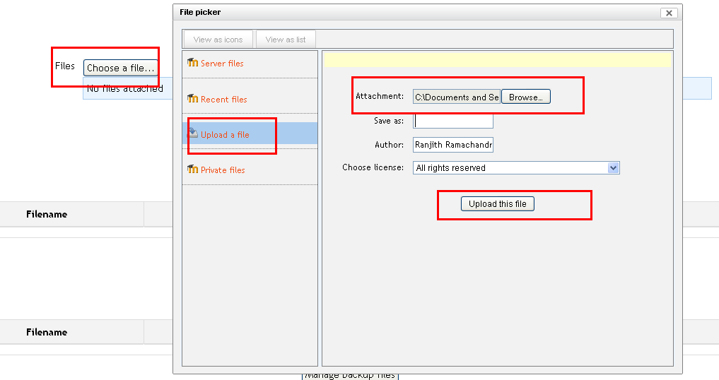
- Once the file is uploaded, click the ‘Restore’ button. See the screen grab below.
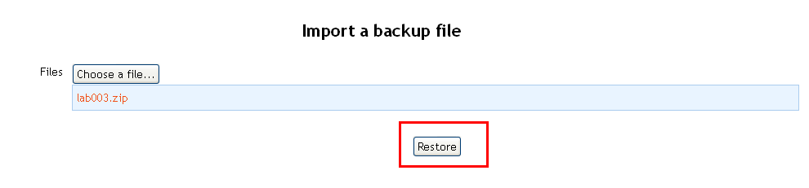
- On the next screen, it will show the backup details and the format of the backup file (if it’s IMS CC package, it must show the back format as ‘IMS Common Cartridge 1.0). Click the continue button.
- Next page to determine where we need to restore this package on Moodle. Under the ‘Restore in to this course’ section, select the radio button for ‘Merge the backup course into this course’ and click ‘Continue’ button.
- On the next page, it will show the ‘Restore settings’. No need to change any settings on this page and click the ‘Next’ button on the right.
- On the next page, it will show the ‘Course settings’. No need to change any settings on this page and click the ‘Next’ button on the right.
- The next page is again shows the ‘Restore settings’ and ‘Course settings’. If the user needs to change any of those settings, then he/she can click the previous button and can change those settings. Click the ‘Perform Restore’ button to continue the import process.
- This will actually start the import process. This process will take time depends on the course size and its contents. Once the restore process is successful, it will show the screen as follows.
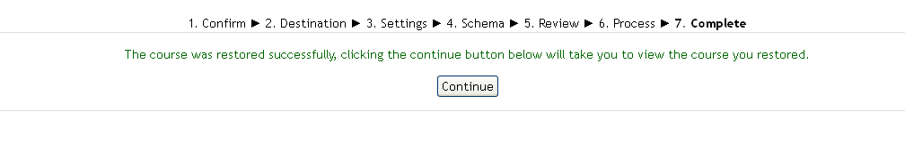
- Click the ‘Continue’ button and it will take you back to the course page. You can now review the course contents which are imported from the package.

Importing a IMS CC v1.0 package in to Canvas
Follow the instructions given in the link: -
http://guides.instructure.com/m/4152/l/82272-how-do-i-import-content-from-blackboard-6-7-8-9-into-canvas

Importing a IMS CC v1.0 package in to Sakai 2.9.1/Sakai 10 (with Lesson Feature)
- Login to Sakai with the instructor login
- Click on the course where the IMS Common Cartridge needs to be imported. (If no course has been created, put a request to administrator to create a blank course shell with required details (such as course name, enrollment etc…)
- Click the ‘Lessons’ link on the left frame (If the ‘Lessons’ link is not available on left, go to ‘Site Info’ and you can add it by ‘Edit Tools’ option on that page)

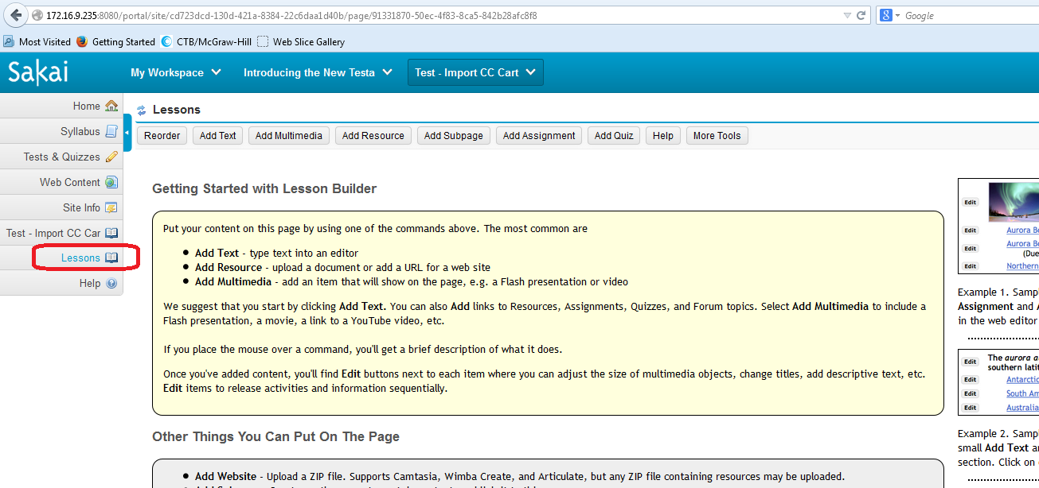

- On ‘Lessons’ page, click ‘More Tools’ button and a drop-down menu will appear. From the drop-down menu, click the ‘Import CC’ option.
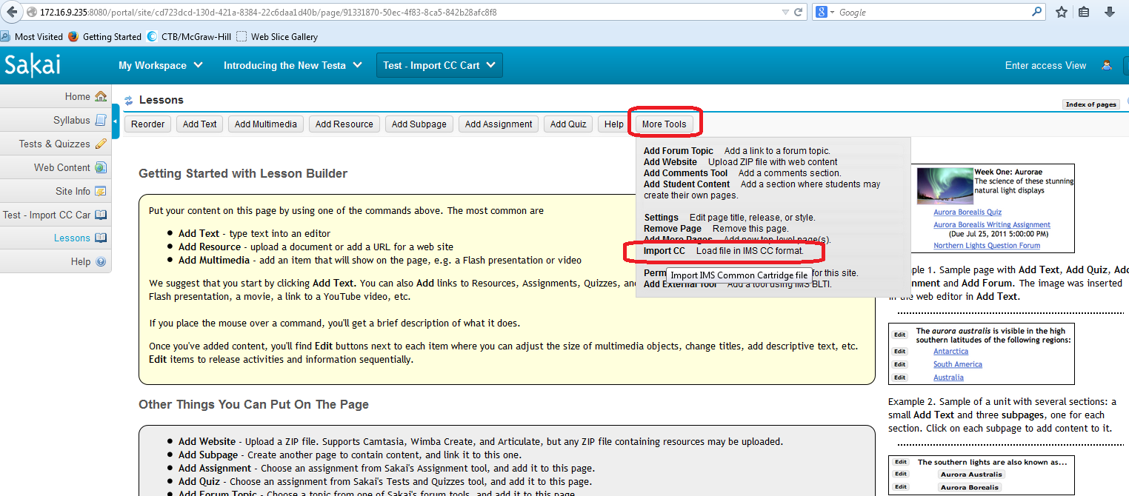
- Browse the IMS CC package on your local machine by clicking ‘Browse’ button and click ‘Save’ button to continue the import process. This process depends upon the course file size and its contents.
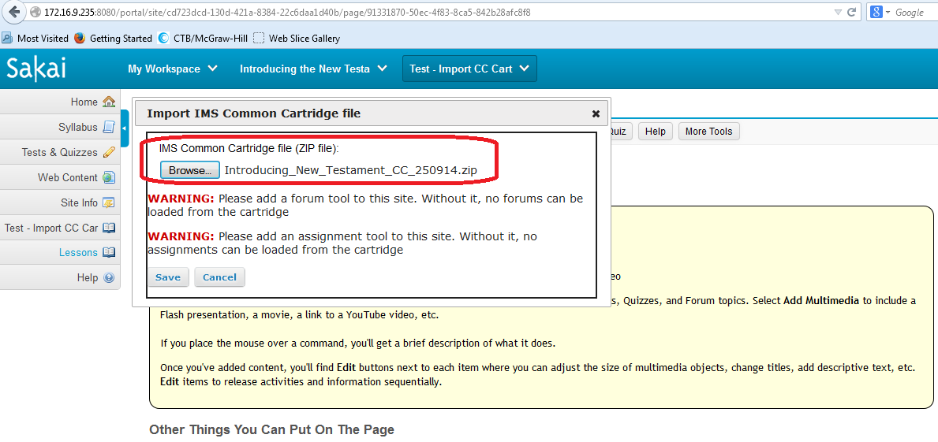

- Once the IMS CC is imported, we can review the items on the course. The course content Area will be appearing on the left frame. The name of that content area will be defined on the ‘imsmanifest.xml’ in the IMS CC package. Please see the screen grab for more details.
Screen grab of XML

